***UNIVERSITY OF VICTORIA***

***Department of Electrical and Computer Engineering***

***CSC 546 Operational Research II***

***PROJECT REPORT***

***Title: Simulation of Tim Hortons Daily Operation***

***Report Submitted on: Dec.10th, 2025***

***Names:***

***Da Zhang (V01062902)***

***Yuanming Wang (V01028720)***

1. ***Introduction***
   1. **Project Description**

The project models the daily operation of a Tim Hortons outlet, focusing on three main customer channels, namely,

* **Walk-in counter service**
* **Drive-thru**
* **Mobile orders**

Customers from each channel place orders that flow through a shared kitchen network, consisting of beverage, hot-food, and packing stations. Finished items are delivered via pickup shelves (for counter and mobile orders) or the drive-thru window (for drive-thru orders). Dine-in customers, which is a subset of walk-in customers, use limited seating that must be cleaned before reuse.

The system is modeled as a queueing network with stochastic arrivals and service times. Each service node (cashier, kitchen stations, etc.) follows appropriate queuing behaviour (e.g., M/M/1). Constraints such as limited shelf capacity, balking of drive-thru, and reneging of mobile orders are pre-determined and included in the simulation.

* 1. **Goal of the Simulation Study**

The goal is to **maximize daily profit while maintaining acceptable customer service levels** by optimizing the following

* **Staffing levels** (cashiers, cooks, baristas, bussers)
* **Equipment use** (urn size, espresso machines, toasters)
* **Operational policies** (prioritization, brew schedule, pickup shelf capacity)

The simulation also evaluates service-level performance, such as:

* 90th percentile waiting time targets for drive-thru customers
* SLA, Service Level Agreement, violation rates for mobile pickup readiness.
  1. **Purpose of the Simulation**

The simulation serves to analyze throughput, waiting times, resource utilization, and customer behaviour(reneging/balking), support data-driven decisions on staffing and process configurations, and quantify the trade-off between profitability and service quality.

1. ***Simulation Explanation***
   1. **Simulation Model**

For simplicity, the whole simulation has been divided into three sub-stages, **Ordering stage, Kitchen & Packaging stage, and Pickup & Dine-in stage**. Within the Ordering stage, customers place and pay for their orders, either through walk-in, drive-thru or mobile app channels. At the end of this stage, each order (from any channel) joins the shared kitchen network for food and drink preparation and packing. Within the Kitchen & Packaging stage, food and beverage items are prepared, then pack orders for pickup or delivery to customers. At the end of this stage, the completed orders will move to the pick-up shelf for counter and mobile customers, or drive-thru the drive-thru customers.

**Stage 1: Ordering Stage**

|  |  |  |  |
| --- | --- | --- | --- |
| **Component** | **Channel** | **Queueing Behavior** | **Notes** |
| Cashier Counter | Walk-in customers | M/M/1 | Single-server queue; customers arrive, wait and are served by available cashiers. |
| Order Station  (drive-thru) | Drive-thru | M/M/1 | Vehicles queue up to place orders. |
| Mobile Order Entry | Mobile App | Scheduled arrivals  (with certain distributed arrival time) | No queue at ordering – orders enter the system based on promised pickup times. |

**Stage 2: Kitchen & Packaging Stage**

|  |  |  |
| --- | --- | --- |
| **Component** | **Queueing Behavior** | **Notes** |
| Beverage station  (brewed coffee urns) | M/M/c (finite buffer) with blocking/replenishment | Multiple urns in parallel; may block if urns need refilling |
| Espresso Machine | M/M/1 (finite buffer) | Capacity limit and maintenance downtime |
| Hot-Food Line | M/M/c | Multiple cooks in parallel |
| Packing station | M/M/1 queue (FIFO) | Service starts only when all food and drink items are ready |

**Stage 3: Pickup & Dine-In Stage**

|  |  |  |
| --- | --- | --- |
| **Component** | **Queueing Behavior** | **Notes** |
| Pickup Shelf  (for counter & mobile orders) | M/M/c | Blocking occurs if the shelf is full; new completed orders cannot be packed |
| Pickup Window  (for drive-thru) | M/M/1 with balking | Vehicles queue to pay and receive food; may balk if line too long |
| Dine-in Area | M/M/c | After pick-up, dine-in customers occupy tables; tables are cleaned before reuse. |

There are three types of special customer behaviours that may happen depending on the status of the nodes within each stage:

1. **Balking** may happen at the drive-thru order queue (in the Ordering Stage) before customers reach the order station (these two service points share the same queue), since if the external vehicle queue is already full or too long, which ultimately reduces arrivals into the drive-thru subsystem, new arrivals may decide not to enter the system.
2. **Reneging** may happen at the mobile order pickup shelf, since the mobile customers will leave without collecting their orders if the items are not ready by the promised pickup time, which represents lost sales and customer dissatisfaction and incurs penalty in profit metric.
3. **Blocking** may occur between packing station and pick-up shelf, in the transition from the Kitchen & Packaging stage to the Pickup & Dine-in stage. This happens when the pickup shelf is at full capacity, the packing station cannot release completed orders, so upstream preparation pauses and blocks, causing congestion and idle time in the kitchen network.
   1. **Simulation Parameters and initial Base-Line set-up**
4. Revenue & Cost
5. Revenue:

These values per item are taken from realistic Tim Hortons and comparable fast-food coffee chain prices. They anchor the profit calculation in reality so any setting scenarios are financially meaningful, and preserve the correct relative profitability, namely brewed coffee is often associated with low revenue margin, espresso drinks with high margin and hot foot with the medium margin.

* 1. Brewed coffee $2.10 per cup
  2. Espresso drink $4.25 per shot
  3. Hot food $3.75 per item

1. Order:

To reflect the reality, each customer has been assigned probabilities of ordering the items, namely, brewed coffee, espresso drink and or a hot food item. The orders are set that each customer entering the shop must order at least one item from the manual for all of the 3 customer arriving channels.

* 1. Each customer has an 80% probability of ordering a brewed coffee
  2. Each customer has a 50% probability of ordering an Espresso drink
  3. Each customer has a 50% probability of ordering a hot food item

1. Labour:

The objective is to optimize staffing to maximize profit, so labour cost must be realistic, which prevents recommending unrealistic overstaffing. Role-differentiated wages allow the model to trade off in terms of the questions such as “Is a second barista worth it?”, “Is an extra cook profitable?”, or “Is it worth adding a food runner at peak times?”. If all roles had the same wage, this economic trade-off would be lost to track.

* 1. 1 Cashier $17 per hour per person
  2. 3 Cooks $18 per hour per person
  3. 4 Baristas $18 per hour per person
  4. 2 Drive-thru staffs $17 per hour per person
  5. 1 Packer $17 per hour per person
  6. 1 Busser $16 per hour per person

1. Food/Beverage COGS (Cost of Goods Sold):

A single blended COGS helps to simplify the calculation of profit and match realistic weighted averages of actual menu mixes, while keeping profitability per item reasonable. In simulation, we want to capture the trade-off between column and cost.

* 1. 35% of item revenue for items

1. Penalty terms:

Tim Hortons and similar brands treat mobile lateness as a low-cost but non-negligible penalty. The penalty of drive-thru wait is deliberately small since wait-time braces matter but don’t directly cost money, and a small penalty gently pushes the optimizer to reduce congestion. The balking penalty is designed to tell the model that losing a car is bad, but not as bad as losing a full order.

* 1. SLA violation $0.5 per mobile order late
  2. Drive-thru wait > 90th percentile target (1minute) incurs $0.2 per breach
  3. Balked vehicle “lost margin” = 40% of expected order revenue

1. Capacity and Maintenance:
   1. Maximum of Single Vehicle Queue Length for drive-thru order and pickup:10 vehicles for the total vehicle length, and 3 vehicles between drive-thru order and pickup windows.
   2. Each Beverage Station (brewed coffee urn) is designed with a capacity of 25, which requires a maintenance/refill of 2 minutes after every 25 orders.
   3. Each Espresso Machine is designed with a capacity of 40, which requires a maintenance/refill of 2 minutes after every 40 orders.
2. Profit (Performance Measure)

$Profit = Revenue - Cost$

Note: Cost is associated with each item sold, which includes labour, food/beverage COGS and possible penalty amounts.

1. Arrival Rates

The table below specifies non-homogeneous Poisson arrival rates (λ, customers/minute) for Walk-in, Drive-thru, and Mobile channels across different time windows of the operating day. These parameters are crucial since the goal of the simulation is to model realistic daily operations of a Tim Hortons outlet and optimize staffing, equipment, and policies under realistic demand patterns. Fast-food coffee shops like Tim Hortons normally experience strong peak demand periods during breakfast, lunch and dinner hours and valley demand in other time periods in a day.

|  |  |  |  |
| --- | --- | --- | --- |
| **Window** | **Walk-in λ**  **(cust/min)** | **Drive-thru λ (cust/min)** | **Mobile order λ (cust/min)** |
| 6AM – 8.30AM | 0.9 | 1.2 | 0.5 |
| 8.30AM – 11AM | 0.6 | 0.8 | 0.4 |
| 11AM – 1.30PM | 0.8 | 1.1 | 0.6 |
| 1.30PM – 5PM | 0.5 | 0.6 | 0.3 |
| 5PM – 8PM | 0.6 | 0.7 | 0.4 |
| 8PM – 10PM | 0.3 | 0.3 | 0.2 |

1. Service Rates

Choosing exponential service distributions (λ, customers/minute) makes the simulation internally consistent with the theoretical model, analytically tractable for doing the what-if analyses, and faithful to the project requirements. Also, exponentially distributed service time also captures real-world variability in service, which would be lost if the service was deterministic. Also, these rates can create realistic congestion patterns essential for policy testing depending on the relationship between the arrive rates λ and service rates u.

|  |  |  |  |
| --- | --- | --- | --- |
| **Sever** | **Number of Server** | **Distribution** | **Initial Parameter λ** |
| Cashier Counter | 1 | Exponential | 2 persons/min |
| Order Station (drive-thru) | 1 | Exponential | 2 persons/min |
| Mobile Order Entry (no queue) | 1 | N/A | N/A |
| Beverage Station (brewed coffee urns) | 3 | Exponential | 3 orders/min |
| Espresso Machine | 1 | Exponential | 4 orders/min |
| Hot-food Line | 3 | Exponential | 3 orders/min |
| Packing Station | 1 | Exponential | 5 orders/min |
| Pickup Shelf  (for counter & mobile orders) | 20 | Exponential | 50 orders/min |
| Pickup Window  (for drive-thru orders) | 1 | Exponential | 6 orders/min |
| Dine-in Area | 25 | Exponential | 0.167 persons/min |
| Table Cleaning | 1 | Exponential | 3 tables/min |

1. Fixed and Variable Parameters

Here, we classify each parameter as either **objective** or **subjective**—that is, **non-changeable** or **changeable**—from the standpoint of the Tim Hortons owner.

* **Non-changeable parameters (fixed)**:

*Order probability,*

*Food/Beverage COGS,*

*Customer Arrival Rates*

* **Changeable parameters (variable)**:

*Revenue:*

Brewed Coffee: ranging from **$1.75 to $3.75** per cup

Espresso Drink: ranging from **$3.50 to $5.50** per cup

Hot foot: ranging from **$3.00 to $5.00** per item

*Labour*: ranging from **$16 to $19** per hour and staff allocation per role can be varied from **1 to 3**

*Service Rates*: ranging from **0.8 to 1.2** per min

*Penalty Amount*:

SLA violation (mobile order): ranging from **$0.4 to $0.8** per order

Drive-thru 90th percentile breach: ranging from **$0.2 to $0.6** per breach

Balked vehicle loss margin: ranging from **20% to 60%** of order revenue

*Capacity and Maintenance*:

Brewed Coffee Urns: each is ranging from **20 to 30** times of use before maintenance. The maintenance time can be varied from **1.6 to 2.4** min.

Espresso Machine: each is ranging from 35 to 45 times of use before maintenance. The maintenance time can be varied from **1.6 to 2.4** min.

*Prioritization*:

The prioritization rule at the packing station can be varied - **FIFO**, **prioritizing dine-in orders, prioritizing mobile orders, or prioritizing drive-thru orders.**

***3. Input modelling***

**3.1 Arrival Rate and Service Rate Distribution Modelling**

To avoid the time and effort required for on-site data collection of arrival and service rates, the **Physical Meaning of Distribution** method was used. This approach selects input distributions based on their underlying physical interpretation, ensuring that the chosen distributions logically reflect real-world system behavior.

* **Position Distribution**: number of independent events that occur in a fixed amount of time or space.
* **Exponential Distribution**: time between independent events, or a process time that is memoryless.

Customer arrivals are modeled using a Poisson distribution because arrivals in a restaurant or cafe occur randomly and independently, which matches the fundamental assumptions of the Poisson process. This is supported by extensive empirical evidence in fast-food and retail operations, and it fits naturally with the nonhomogeneous arrival pattern observed throughout the day.

Service times, on the other hand, are modeled using an exponential distribution because human-operated service tasks exhibit high variability, with many short interactions and a few long ones. This exponential distribution captures this behaviour well and aligns with the M/M/1 queuing structure specified in the project. This ensures consistency with queuing theory and produces realistic waiting-time behaviour in simulation.

***4. Output Analysis***

**4.1 Warm-up Period**

Within each simulation day, we introduced a warm-up period to alleviate the problem of initialization bias, which helps make the system stabilized before collecting data. The length of the warm-up period is determined by observing how quickly the system approaches steady operational behaviour after opening. The preliminary simulations of the Base-Line are run and the performance indicator, profit over time is examined. The warm-up period is then set to a duration long enough for this measurement to stabilize and for the influence of the empty initial state to dissipate, not so long that it removes meaningful operational data. Here, the optimal **warm-up period of 30 minutes** is chosen for this simulation study.

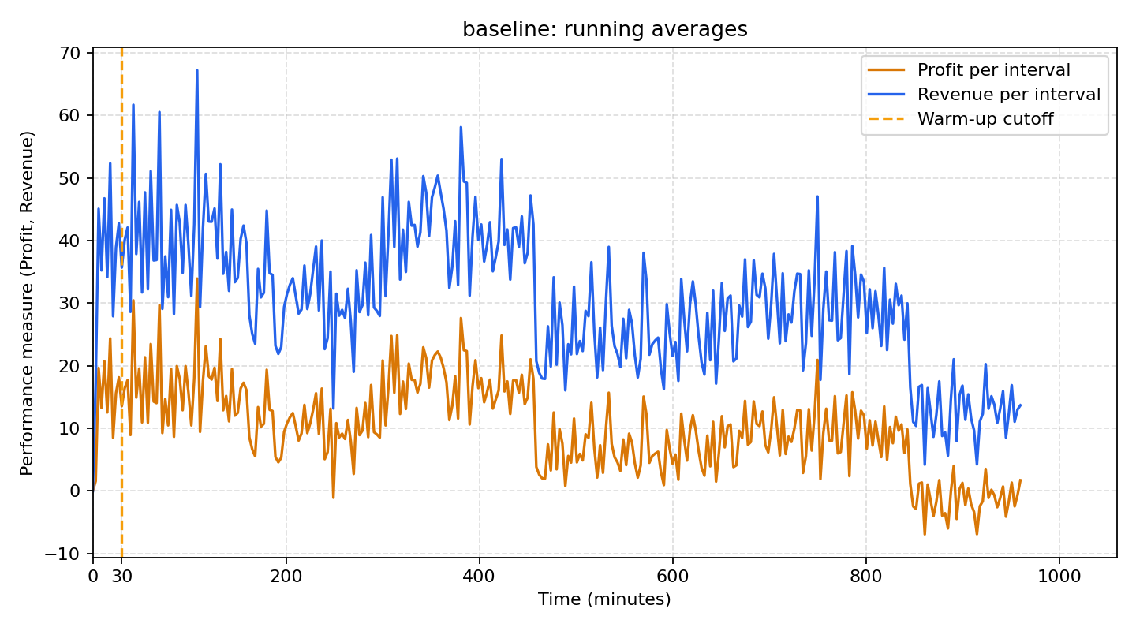

**4.2 Absolute Performance for the Base-Line System Design**

For the base-line scenario consisting of the initial combination of system variables, the simulation is executed using five different random seeds. The performance measure of interest—**Profit** —is recorded for each replication. These values form the across-replication sample for that scenario. The **Across-Simulation Average Profit**, denoted , is then computed, along with the sample standard deviation and a confidence interval estimating the true mean profit for the base-line design.

The reference for **The within replication and across replication data** for a single system design are displayed below, where the ij is denoted as the individual profits by serving each individual customer, which is not calculated implicitly by the program, and the program calculated profit by each replication is denoted by i. refers to the width of the confidence interval for the true mean profit.

|  |  |  |
| --- | --- | --- |
| **Replication** | **Within Replication** | **Across Replication** |
| 1 | 11 , 12, …, 1n1 | 1 |
| 2 | 21 , 22, …, 2n2 | 2 |
| 3 | 31 , 32, …, 3n3 | 3 |
| 4 | 41 , 42, …, 4n4 | 4 |
| 5 | 51 , 52, …, 5n5 | 5 |
|  |  | , , |

***Results***

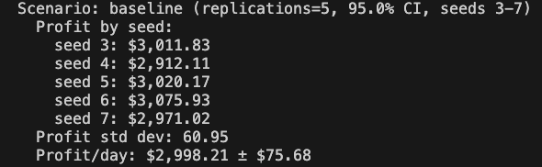

|  |  |
| --- | --- |
| **Replication** | **Across Replication Profits** |
| 1 (seed 3) | 1 = 3011.83 |
| 2 (seed 4) | 2 = 2912.11 |
| 3 (seed 5) | 3 = 3020.17 |
| 4 (seed 6) | 4 = 3075.93 |
| 5 (seed 7) | 5 = 2971.02 |

*Sample Profit Mean: $\underline{θ} =\frac{1}{R}\sum{}(θ_{i})= 2998.21$*

*Sample Profit Standard Deviation: $S=\sqrt{\frac{1}{R}\sum{}(θ_{i}-\underline{θ})^{2}}= 60.95$*

*95% Confidence Interval of the True Mean Profit: $\underline{θ}±t_{0.025,R-1}\frac{S}{\sqrt{R}} = [2922.53, 3073.89]$*

From the confidence interval, we can conclude that, with 95% confidence, the true mean profit of this baseline system design lies in between $2922.53 to $3073.89 per day. That is, if we repeat this study many times, 95% of the confidence interval constructed would contain the true mean daily profit.

**4.3 Performance Comparison of Multiple System Design**

**4.3.1 All system pairs comparison across all designs**

**1）Variable Parameters for each Scenario**

***Revenue***

|  |  |  |  |
| --- | --- | --- | --- |
|  | **Price (Base-Line)** | **Price (Scenario #1)** | **Price (Scenario #2)** |
| Brewed Coffee | $2.10 per cup | $2.75 per cup | $3.75 per cup |
| Espresso Drink | $4.25 per shot | $4.5 per cup | $5.5 per cup |
| Hot Food | $3.75 per item | $4 per cup | $5 per cup |

***Labour***

|  |  |  |  |
| --- | --- | --- | --- |
|  | **Wage (Base-Line)** | **Wage (Scenario #1)** | **Wage (Scenario #2)** |
| Cashier | $17 per hour | $17.5 per hour | $16 per hour |
| Cook | $18 per hour | $17.5 per hour | $16 per hour |
| Barista | $18 per hour | $17.5 per hour | $16 per hour |
| Drive-thru Staff | $17 per hour | $17.5 per hour | $16 per hour |
| Packer | $17 per hour | $17.5 per hour | $16 per hour |
| Busser | $16 per hour | $17.5 per hour | $16 per hour |

***Service Rates***

|  |  |  |  |  |  |  |
| --- | --- | --- | --- | --- | --- | --- |
| **Sever** | **Number of Server (Base-Line)** | **Number of Server**  **(Scenario #1)** | **Number of Server**  **(Scenario #2)** | **Service Rate**  **(Base-Line)** | **Service Rate**  **(Scenario #1)** | **Service Rate**  **(Scenario #2)** |
| Cashier Counter | 1 | 1 | 1 | 2 persons/min | 1.25 persons/min | 2.22 persons/min |
| Order Station (drive-thru) | 1 | 1 | 1 | 2 persons/min | 1 persons/min | 2 persons/min |
| Mobile Order Entry (no queue) | 1 | 1 | 1 | N/A | N/A | N/A |
| Beverage Station (brewed coffee urns) | 3 | 2 | 1 | 3 orders/min | 1 orders/min | 3.33 orders/min |
| Espresso Machine | 1 | 2 | 1 | 4 orders/min | 1 orders/min | 5 orders/min |
| Hot-food Line | 3 | 2 | 1 | 3 orders/min | 1 orders/min | 3 orders/min |
| Packing Station | 1 (FIFO) | 1 (Mobile order prioritization) | 1 (Dine-in order prioritization) | 5 orders/min | 2 orders/min | 5 orders/min |
| Pickup Shelf  (for counter & mobile orders) | 20 | 20 | 20 | 50 orders/min | 2 orders/min | 20 orders/min |
| Pickup Window  (for drive-thru orders) | 1 | 1 | 1 | 6 orders/min | 2 orders/min | 5.4 orders/min |
| Dine-in Area | 25 | 20 | 14 | 0.167 persons/min | 0.05 persons/min | 0.167 persons/min |
| Table Cleaning | 1 | 2 | 1 | 3 tables/min | 0.5 tables/min | 2.4 tables/min |

***Penalty***

|  |  |  |  |
| --- | --- | --- | --- |
|  | **Amount (Base-Line)** | **Amount (Scenario #1)** | **Amount (Scenario #2)** |
| SLA Violation | $0.5 per mobile order | $0.4 per mobile order | $0.4 per mobile order |
| Drive-thru wait | $0.2 per breach | $0.2 per breach | $0.2 per breach |
| Balked vehicle | 40% of the revenue | 40% of the revenue | 20% of the revenue |

**2）Scenario Comparison using Bonferroni Approach**

For each scenario consisting of a specific combination of system variables, the simulation is executed using five different random seeds. The performance measure of interest—**Profit** —is recorded for each replication. These values form the across-replication sample for that scenario. The **Across-Simulation Average Profit**, denoted , is then computed, along with the sample standard deviation and a confidence interval estimating the true mean profit for a specific design.

Noticed that, for the purpose of comparing each pair of designs, **the variance reduction technique of Common Random Number (CRN)** was implemented - the five random seeds that were used in the Absolute Performance for the Base-Line System Design are used for obtaining the Across-Simulation Average Profit for each scenario.

Similar to the performance analysis for a system design in 4.2.1, the across replication profits by each replication are recorded and then the Average Across-Simulation Average Profit $\underline{θ}$, sample standard deviation $S$, and the width $H$ confidence intervals for the true mean profit are computed.

The total number of comparisons using the Bonferroni Approach is $C =\frac{K(K-1)}{2}$, where K is the number of system designs. In our case, the number of system design $K =3$, thus total number of comparisons $C = 6$. Assuming the significance level $α = 0.05$, then the individual comparison’s significance level $α_{i }= \frac{α}{C} = 0.01667$, and $t_{0.00833, 4 }= 3.9575$.

**Comparison between Base-Line and Scenario #1**

|  |  |  |  |
| --- | --- | --- | --- |
| **Replication** | **Across Replication (Base-Line)** | **Across Replication**  **(Scenario #1)** | **Across Replication Difference** |
| 1 (seed 3) | 1,0 = 3011.83 | 1,1 = 3398.89 | $D_{1}=$-387.06 |
| 2 (seed 4) | 2,0 = 2912.11 | 2,1 = 3288.19 | $D_{2}=$-376.08 |
| 3 (seed 5) | 3,0 = 3020.17 | 3,1 = 3287.82 | $D_{3}=$-267.65 |
| 4 (seed 6) | 4,0 = 3075.93 | 4,1 = 3312.21 | $D_{4}=$-236.28 |
| 5 (seed 7) | 5,0 = 2971.02 | 5,1 = 3426.30 | $D_{5}=$-455.28 |

*Sample Profit Mean: ${\underline{D}}_{base vs \#1} =\frac{1}{R}\sum{}(D_{i})= -344.47$*

*Sample Profit Standard Deviation: $S=\sqrt{\frac{1}{R}\sum{}(D_{i}-{\underline{D}}_{base vs \#1})^{2}}=90.41$*

*Confidence Interval of the True Mean Profit: ${\underline{D}}_{base vs \#1}±t_{0.00833,R-1}\frac{S}{\sqrt{R}} = [-456.73, -232.21]$*

The confidence interval for the true mean difference between the Base-Line and Scenario #1, so Scenario #1 has a significantly larger mean profit performance than the Base-Line at overall family-wise level $α = 0.05$.

**Comparison between Base-Line and Scenario #2**

|  |  |  |  |
| --- | --- | --- | --- |
| **Replication** | **Across Replication (Base-Line)** | **Across Replication**  **(Scenario #2)** | **Across Replication Difference** |
| 1 (seed 3) | 1,0 = 3057.01 | 1,2 = 6921.46 | $D_{1}=$-3909.63 |
| 2 (seed 4) | 2,0 = 2938.55 | 2,2 = 6742.74 | $D_{2}=$-3830.63 |
| 3 (seed 5) | 3,0 = 3055.60 | 3,2 = 6904.60 | $D_{3}=$-3884.43 |
| 4 (seed 6) | 4,0 = 3098.10 | 4,2 = 6972.47 | $D_{4}=$-3896.54 |
| 5 (seed 7) | 5,0 = 2962.64 | 5,2 = 6770.51 | $D_{5}=$-3799.49 |

*Sample Profit Mean: ${\underline{D}}_{base vs \#2} =\frac{1}{R}\sum{}(D_{i})= -3864.14$*

*Sample Profit Standard Deviation: $S=\sqrt{\frac{1}{R}\sum{}(D_{i}-{\underline{D}}_{base vs \#2})^{2}}= 46.99$*

*Confidence Interval of the True Mean Profit: ${\underline{D}}_{base vs \#2}±t_{0.00833,R-1}\frac{S}{\sqrt{R}} = [-3922.49, -3805.79]$*

The confidence interval for the true mean difference between the Base-Line and Scenario #2, so Scenario #2 has a significantly larger mean profit performance than the Base-Line at overall family-wise level $α = 0.05$.

**Comparison between Scenario #1 and Scenario #2**

|  |  |  |  |
| --- | --- | --- | --- |
| **Replication** | **Across Replication (Scenario #1)** | **Across Replication**  **(Scenario #2)** | **Across Replication Difference** |
| 1 (seed 3) | 1,1 = 3398.89 | 1,2 = 6921.46 | $D_{1}=$-3522.57 |
| 2 (seed 4) | 2,1 = 3288.19 | 2,2 = 6742.74 | $D_{2}=$-3454.55 |
| 3 (seed 5) | 3,1 = 3287.82 | 3,2 = 6904.60 | $D_{3}=$-3616.78 |
| 4 (seed 6) | 4,1 = 3312.21 | 4,2 = 6972.47 | $D_{4}=$-3660.26 |
| 5 (seed 7) | 5,1 = 3426.30 | 5,2 = 6770.51 | $D_{5}=$-3344.21 |

*Sample Profit Mean: ${\underline{D}}_{\#1 vs \#2} =\frac{1}{R}\sum{}(D_{i})= -3519.67$*

*Sample Profit Standard Deviation: $S=\sqrt{\frac{1}{R}\sum{}(D_{i}-{\underline{D}}_{\#1 vs \#2})^{2}}= 126.72$*

*Confidence Interval of the True Mean Profit: ${\underline{D}}_{\#1 vs \#2}±t_{0.00833,R-1}\frac{S}{\sqrt{R}} = [-3677.02, -3362.33]$*

The confidence interval for the true mean difference between the Scenario #1 and Scenario #2, so Scenario #2 has a significantly larger mean profit performance than the Scenario #1 at overall family-wise level $α = 0.05$.

Among the 3 pair-wise comparisons using Bonferroni-adjusted confidence intervals, all the confidence intervals are strictly negative. Thus, at overall family-wise error level $α = 0.05$, we can conclude that Scenario #2 has a significantly larger mean profit performance than Scenario #1, and Scenario #1 has a significantly larger mean profit performance than the Base-Line.

**3) Visual Profit Performance Comparison**

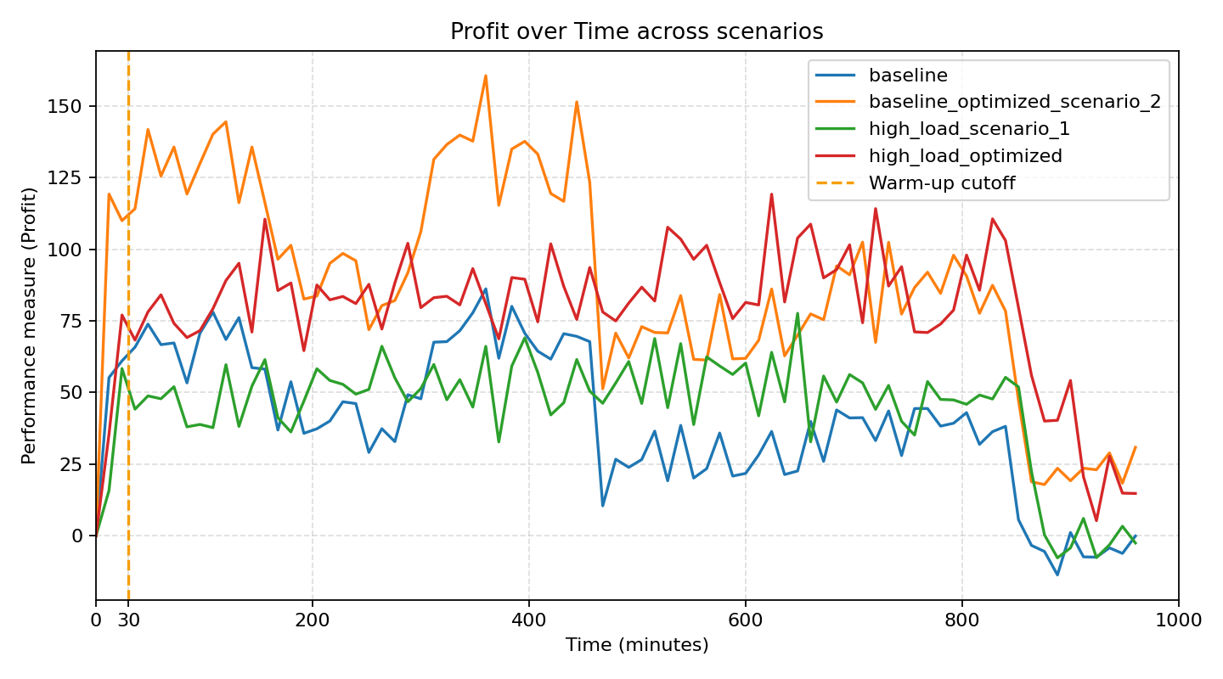

**4.3.2 Selection of the Best (Largest Profit 𝜃)**

For the way of finding the optimized profit, we implemented a grid-based coordinate ascent with optional ranges that are specified in section 2.2(5). This approach trades exhaustive combinatorial search for a much cheaper, dimension-wise search, giving faster, repeatable improvements at the cost of not guaranteeing the global optimum. A comprehensive explanation of the grid-based coordinate ascent search is introduced below:

Grid construction: For each tunable dimension (service multipliers or absolute service times, capacities, wages, penalties, prices) it builds a discrete grid from user-specified bounds and steps.

Coordinate ascent loop: Starting from the Scenario’s current configuration, it iterates over dimensions one at a time. For each dimension, it sweeps the grid while holding all other parameters fixed, selects the value that maximizes profit, and commits it. This repeats for a small number of passes to refine the solution without exploding into a full Cartesian search.

Profit evaluation: Each candidate is run for several replications using consecutive seeds; the average daily profit across those replications is the objective, which smooths randomness.

Bound enforcement: all candidates, including the initial base-line settings are clamped to their configured ranges to prevent drifting out of bounds when using absolute-service-time mode or when scanning wages/penalties/prices.

Scenario handling: it applies overrides from selected scenarios before searching, so we can target specific base-lines instead of all scenarios.

Output: The best-found configuration is printed as a read-to paste scenario block, including services, capacities, penalties, costs (wages/prices) and simulation settings.

The combination of configurations given by the optimization algorithm for the profit maximization scenario is given blow:

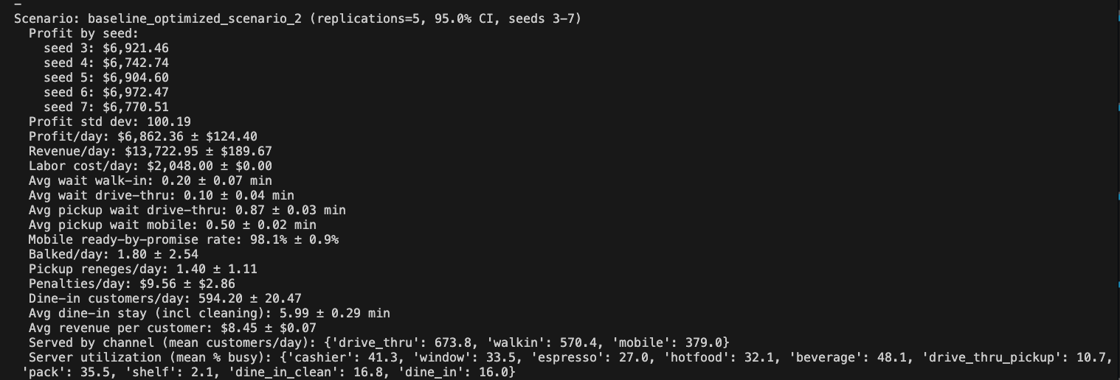

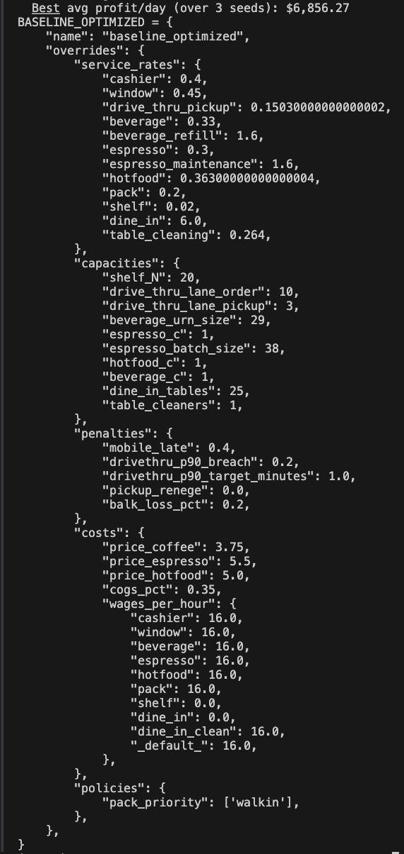

***5. Conclusion***

**5.1 Conclusion based on Simulation Results**

This project developed a discrete-event simulation model to capture the daily operations of a typical Tim Hortons outlet, incorporating three major customer channels—walk-in, drive-thru, and mobile orders—and their interactions with a shared kitchen network. Through systematic experimentation and output analysis, we evaluated three design scenarios using the Common Random Numbers technique and Bonferroni-adjusted confidence intervals to ensure statistically valid comparisons.

The results demonstrate a clear and consistent improvement in average daily profit from the Base-Line to Scenario #1 and further to Scenario #2. All pair-wise confidence intervals for mean profit differences were strictly negative, indicating that Scenario #2 achieved significantly higher profitability than both Scenario #1 and the Base-Line at the overall family-wise significance level. Scenario #2’s improvements stem mainly from reduced wage costs, optimized service rates, and balanced pricing, which together enhanced resource utilization and customer throughput without compromising service quality. These findings validate the simulation’s usefulness as a decision-support tool for operational optimization in quick-service restaurant environments.

**5.2 Limitation and Suggestions**

Despite providing valuable managerial insights, the current model simplifies several real-world complexities. First, customer behavior such as balking and reneging was modeled deterministically, whereas actual behavior may depend on dynamic system states or individual tolerance levels. Second, the study assumed fixed arrival patterns and service-time distributions; incorporating empirically fitted distributions or time-dependent parameters could further improve realism. Third, the optimization used a grid-based coordinate-ascent search that guarantees local but not global optimality; future work could integrate metaheuristics (e.g., genetic algorithms or simulated annealing) or reinforcement-learning methods for more robust global optimization.

In addition, future extensions could explore multi-day operations with inventory management, staff scheduling, and stochastic disruptions such as machine failures. Incorporating real transaction data from Tim Hortons stores would also enhance model validation and allow more precise calibration of arrival and service parameters.

Although the simulation provides meaningful insights, an important limitation lies in the optimization procedure used to identify the best-performing design. The current approach employs a simple coordinate-ascent search, which adjusts one decision variable at a time while keeping others fixed. While easy to implement, this method can stall at a local optimum and does not guarantee finding the global profit-maximizing configuration, especially given the noisy and potentially nonconvex nature of simulation-based objective functions. Future work could strengthen this component by adopting more robust simulation-optimization techniques—such as SPSA, Nelder–Mead, simulated annealing, or metaheuristic global search—as well as adaptive step-size or variance-reduction strategies that allow the algorithm to better navigate noisy performance surfaces.

Overall, the project successfully demonstrated how discrete-event simulation can quantify the trade-off between profitability and service quality and support evidence-based decision making for operational design in service systems like Tim Hortons.

**6. Program and Code Repository**

<https://github.com/yuanmingwang/Profit-Maximizing-Simulation-of-Tim-Hortons-Using-a-Queueing-Network-Model>